Issue Calculated Field DA
- Export clean dataset from supabase
- Import to tableau one by one so I can make model for the dataset, I linked up every table using the PK and so it can formed star schema
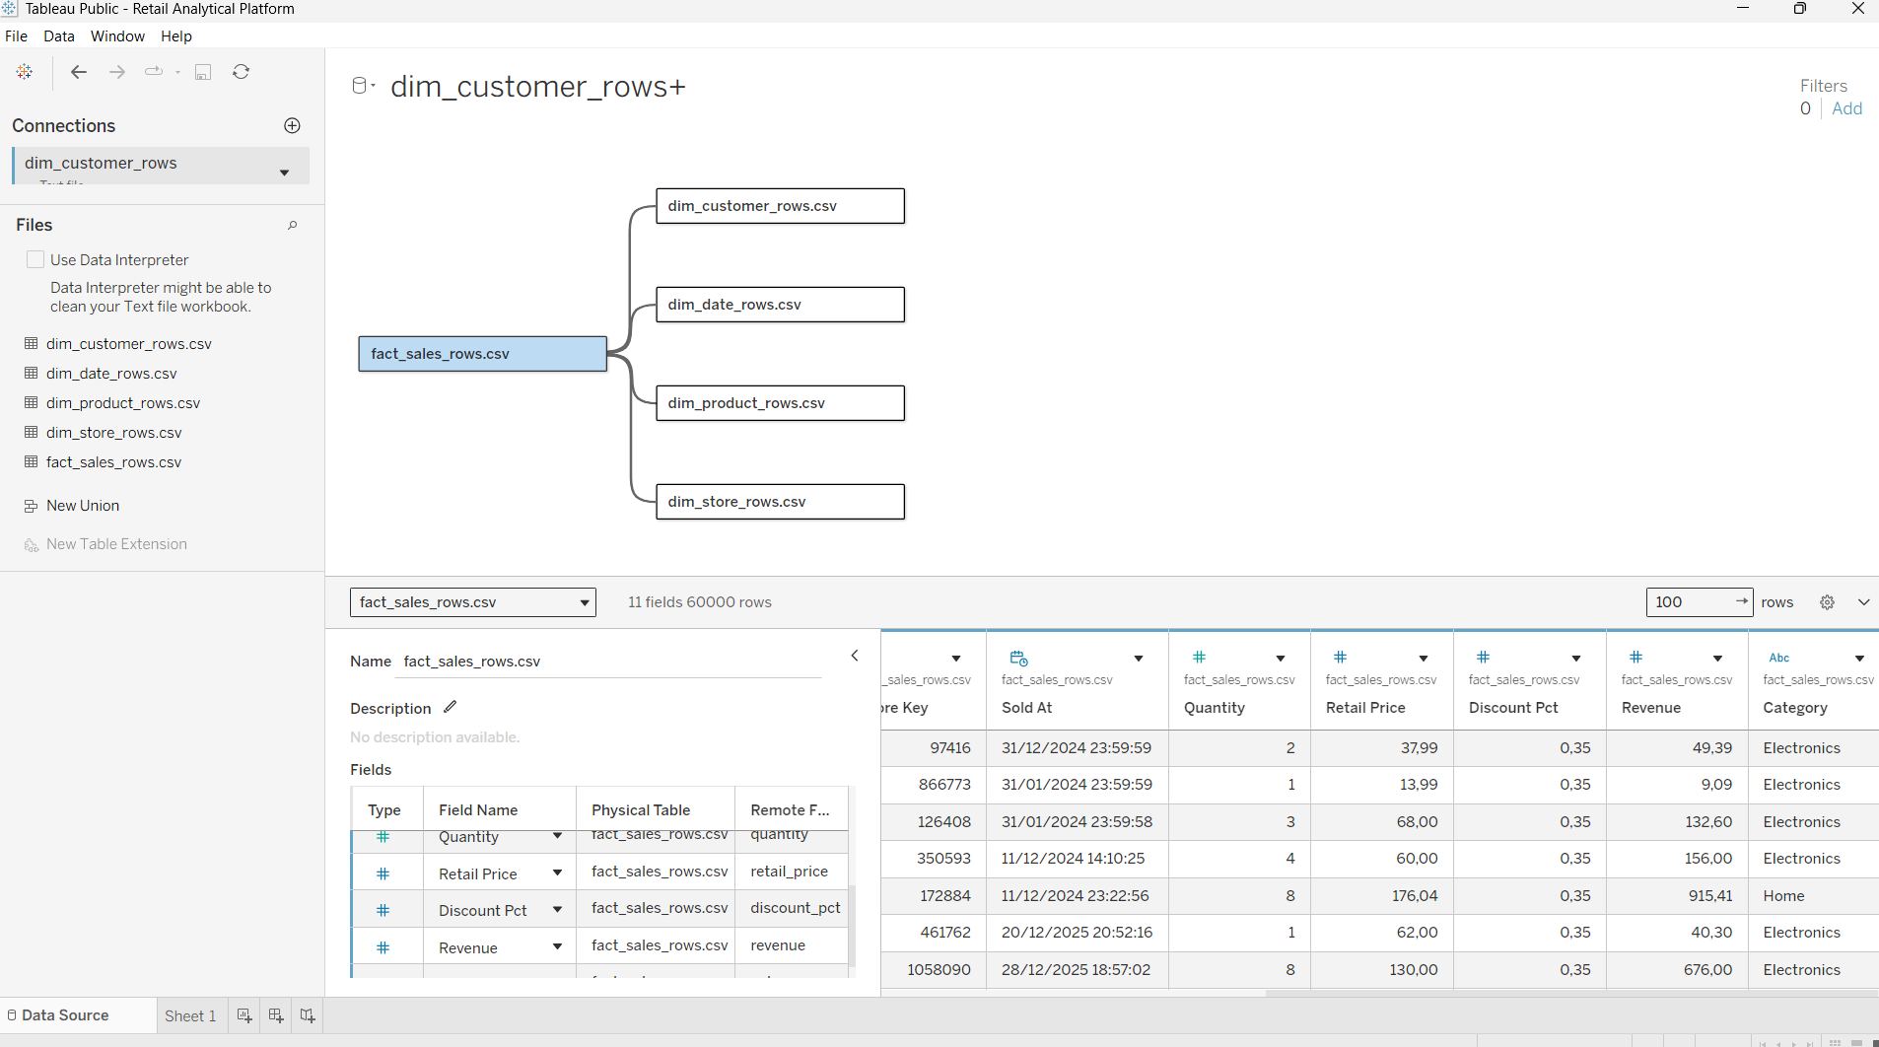
- And then I performed data type conversion because the imported dataset type hasn't been fixed yet in tableau.
- After finishing up the schema, I created calculated field for the dashboard
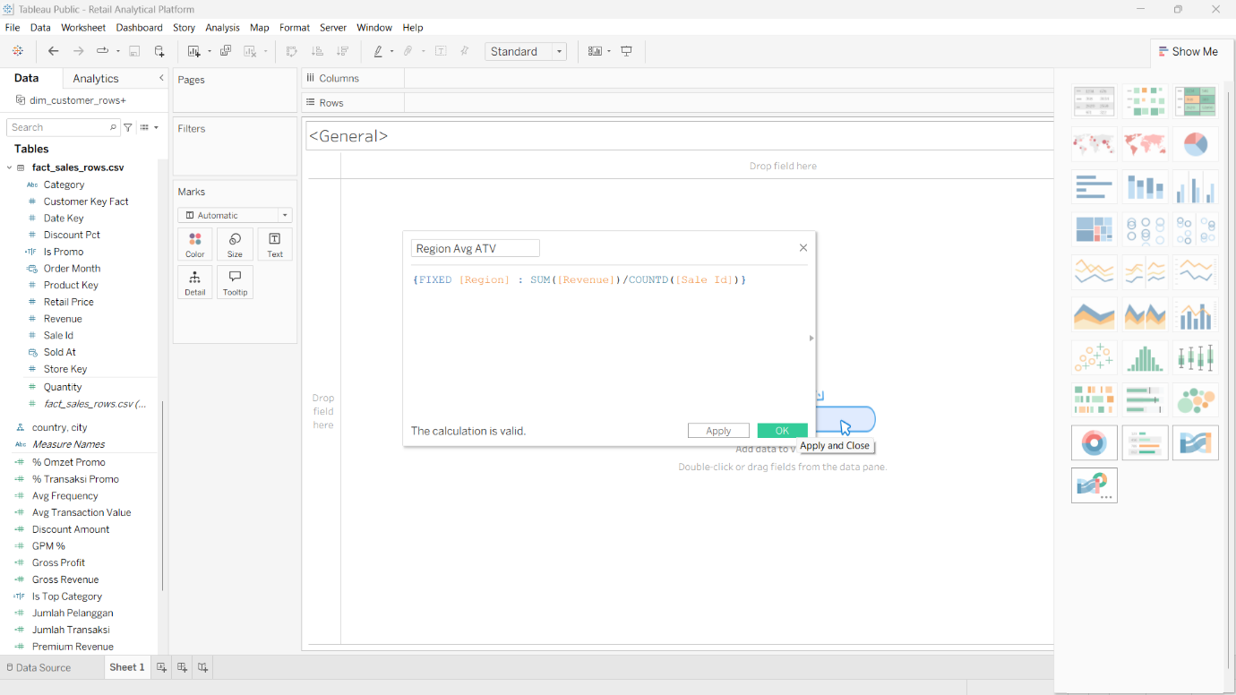
- There are some main measure that can answer the business question like sum revenue, avg frequency, gross revenue, etc.

